5.86: Denote the common magnitude of the maximum acceleration as a. For block A to remain at rest with respect to block B, 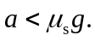 The tension in the cord is then This tension is related to the mass 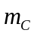 by 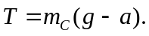 Solving for a yields

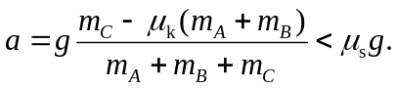

Solving the inequality for 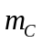 yields

